Three Main Ideas
Volume ? Weight ? Specific gravity ?
Supporting Details
H x L x W = ? Balance ? M1? M2 ?
Irregular Shapes? How to use balance? The equation and
Water displacement ? how it is worked?
How it is measured?
Conclusion
30 points content 10 points organization
Astronomy Picture of the Day
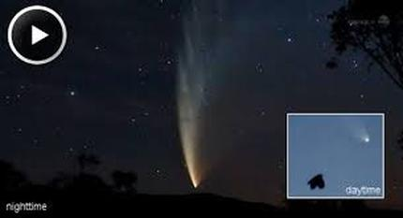
Year of the Comet
2013
Space Photos
Meteor Shower
Juno

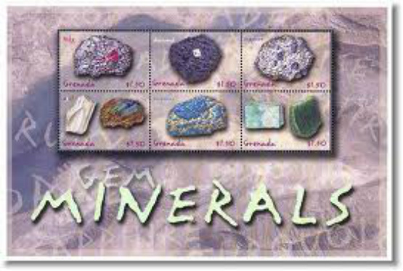
Minerals page 96-111
Key Concepts:
1. Identify the characteristics of minerals. Page 96
2. Explain the three methods of forming minerals. Page 97.
3 What is crystalline structure (Faces)?
4. How to identify minerals?
5. Minerals in our life.
6. Volume, Density, "Specific Gravity" essay.

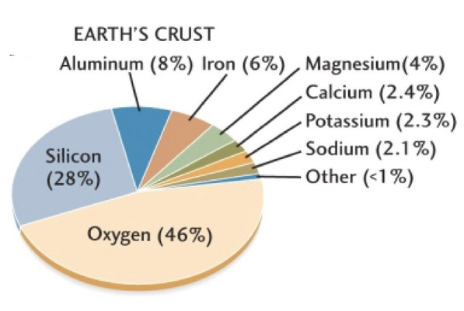
Minerals page 96
There are some 4000 known minerals.
What are the five most common elements in the earth’s crust .p96.
1._______________________ 2._______________________
3._______________________
4._______________________ 5._______________________
6. Compare the amounts of ____and sodium?

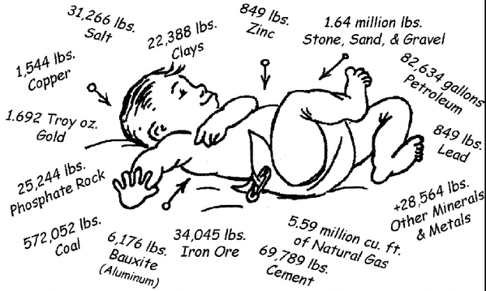
3.6 million pounds of minerals

Mineral Characteristics page 96
7. Occur ______.
8. __.
9. Definite chemical _____. Most are compounds.
10. Atoms are arranged in an orderly ___. Crystals.
11. ___ not alive never been alive.
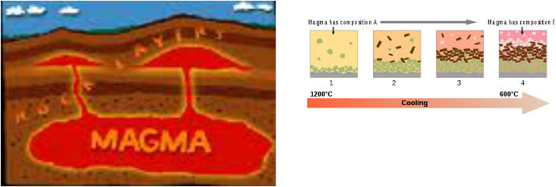
How Minerals Form page 97
12.____ Process :
13. Magma- ___ rock
14. The particles in the hot Magma __ freely. .
15. When the magma starts cool these atoms, molecules and ions move closer together and ___ to form various compounds .
16. As they slow forces of attraction __ the partials together and form grains of minerals.

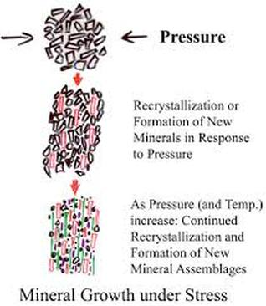
Pressure Process page 97
17.When a rock is subject to high __ and pressure, the minerals can begin to break down .
Coal to a diamond
18.The temperature and pressure becomes great enough to ___ the minerals in solid state, without ____them.
19. The free, atoms, ions and molecules __ in new ways, forming minerals.

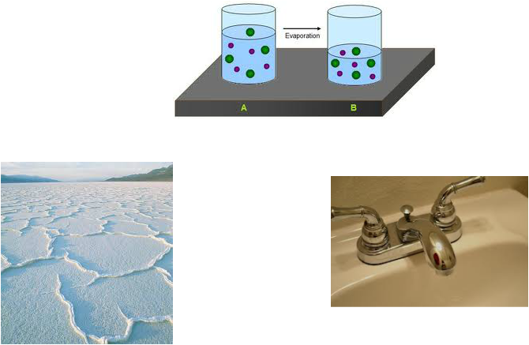
20. _____Process: Water with a mix of particles. As the water evaporates the particles get close and closer. Sodium and chlorine in water form ions. As the water ____ salt is formed.

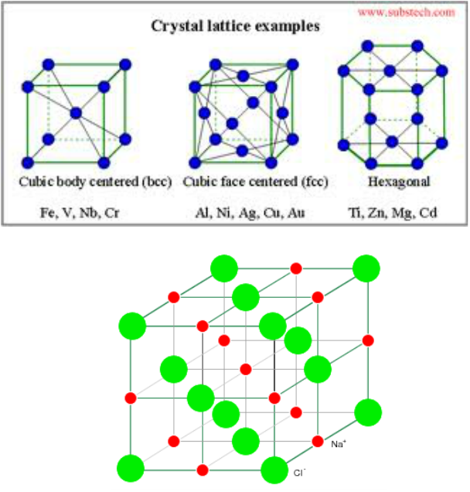

Crystal Structure Page 98-99
21. A crystal is a regular __ solid with smooth surface called crystal ____.
22. All minerals have crystalline ____. Regular _____arrangement of atoms.
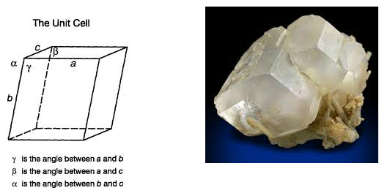
Page 99
23. Note the geometric shapes of the __.
24. Some faces are straight ____ and some are ___.
25. Some are ____, rectangular(_____ faces) or hexagon shaped.(____ faces)

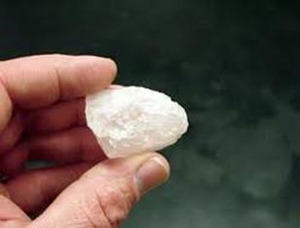
Identifying Minerals page 104

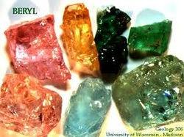
26. _____

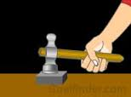
27. Malleable ______ into shape.

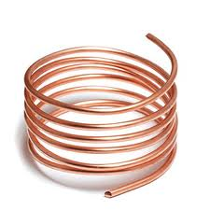
28. Ductile drawn out into a thin _____without crumbling.

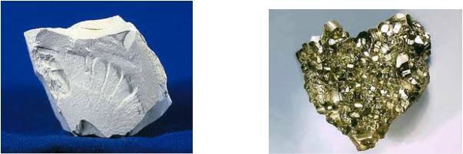
29. Luster/ _____.

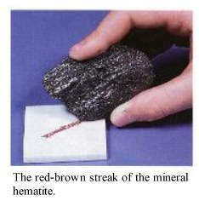
30.Streak ____ of its powder.

Crystal Shape faces
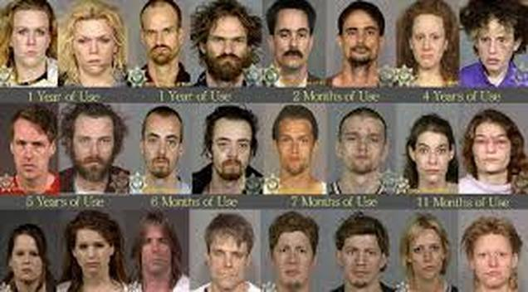
31. Fracture how it ___up.
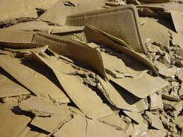
Mineral Uses
Mineral uses
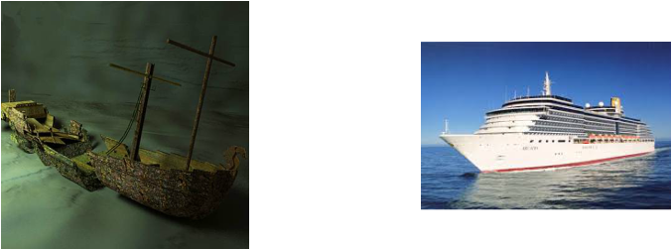
32. Archimedes Principle If an object can ___ the volume of water equal to the weight of the ship, it will float.
33. An object will weigh ___in water.
Iron ships can float?
Wood ships can sink. Why?

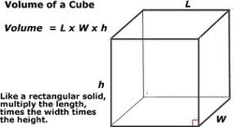
33. Volume ?

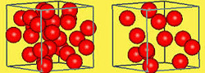
34. Density ?

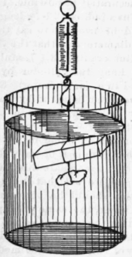
35. Specific Gravity ?

Create a free website with Weebly
<img src="//pixel.quantserve.com/pixel/p-0dYLvhSGGqUWo.gif" style="display: none;" border="0" height="1" width="1" alt="Quantcast"/>

