Alkanes Worksheet

1. Answer the following.
a. What is the general formula for an alkane? __________________________________

b. If a saturated alkane had 15 carbon atoms in it, how many hydrogens would there be? ______
2. Draw all of the possible structure of following types of hydrocarbons using 4 carbon atoms:

a. alkane
b. cycloalkane
3. Give the molecular formula, the structural formula, the condensed structural formula, and the skeletal formula (line drawing) for pentane.

Molecular formula:
Structural formula:
Condensed structural formula:
Skeletal formula (line diagram):
5. Give the molecular formula, the structural formula, the condensed structural formula, and the skeletal formula for 4-ethyl-2,3-dimethylheptane.

Molecular formula:
Structural formula:
Condensed structural formula:
Skeletal formula (line diagram):

6. Give the molecular formula, the structural formula, the condensed structural formula, and the skeletal formula for 3,3-diethyloctane.

Molecular formula:
Structural formula:
Condensed structural formula:
Skeletal formula (line diagram):

7. What is the IUPAC name for the following structure?
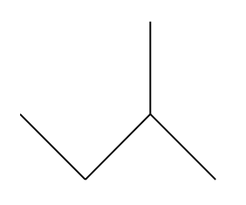

8. What is the IUPAC name for the following structure?

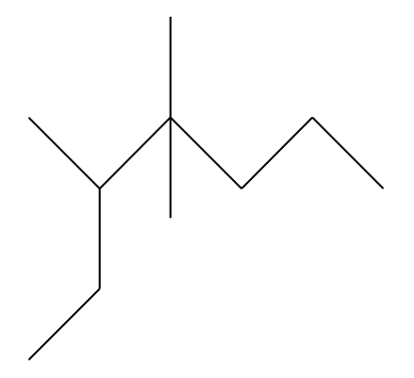

9. Draw and name four isomers of octane.

Solutions:
- a)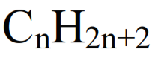 b)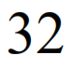
- a)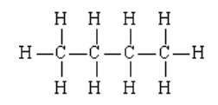 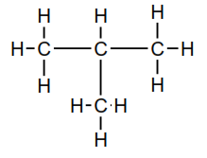 b)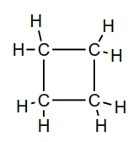
- 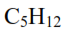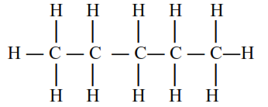
- 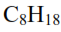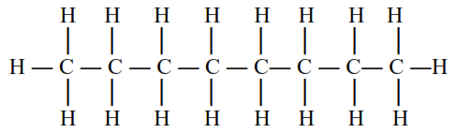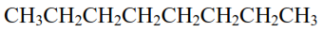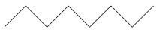
- 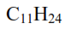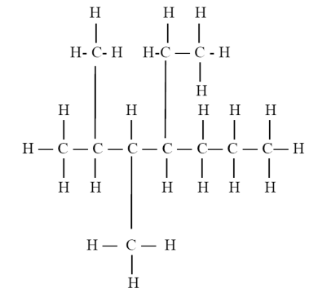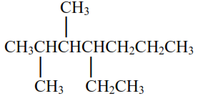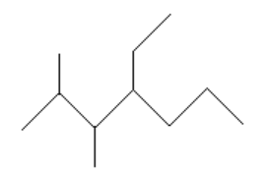
- 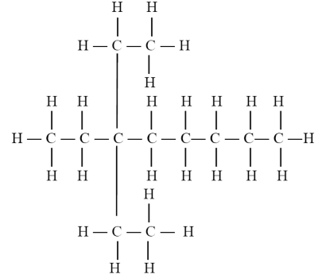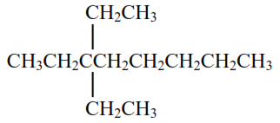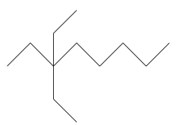

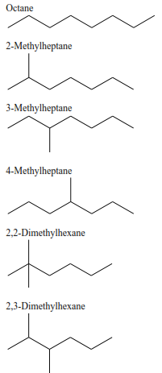 | 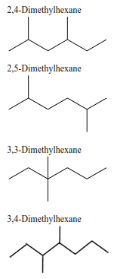 | 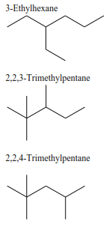  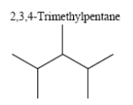 | 