Astronomy Picture of the Day
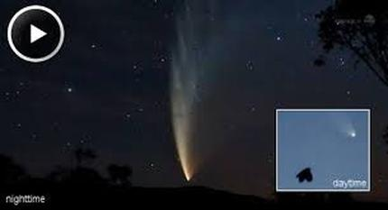
Is ET home?
Sky Telescope

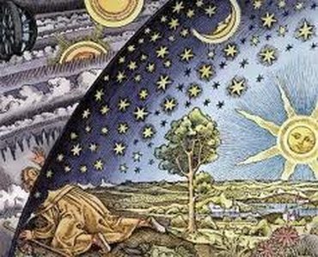
History of Astronomy

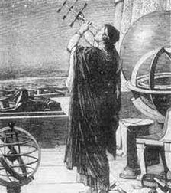
Astronomy the oldest science. Study the heavens.
How did Astronomy influence man?
How to link them?
Farming
The seasons became important; during different times of the year, different stellar patterns appear in the sky. In the spring,Virgo and her accompanying
constellations signal the time to prepare the earth, to plant crops, and to be
wary of floods.
In the fall, Orion rises to indicate
time to harvest and to prepare for winter.
1. How did the night sky help early farmers?

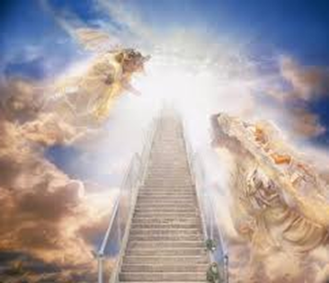
Religion.
2. How would the sky influence religion?

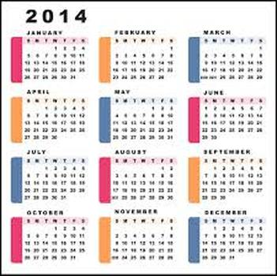
Calendar 5 nontwinkling objects, sun and moon. Moonday, Sunday.
3. How could what is happening in the sky lead to the development of a calendar?

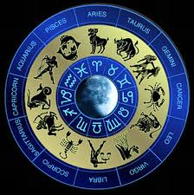
astrology
Heavens controlled events on earth.
4. Why is astrology not a science?

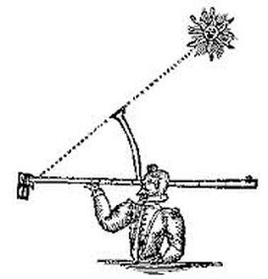
Math measurements.
5. How could math develope from Astronomy?

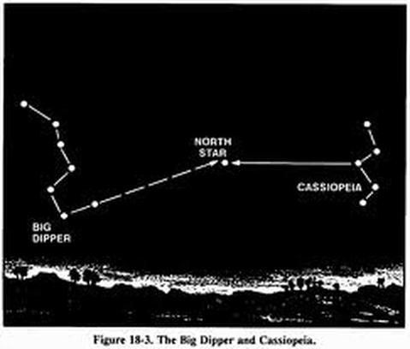
Navigation night stars. Polaris and the pointer stars.
6. How do you find the north star?

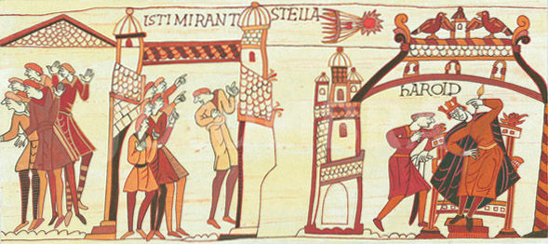
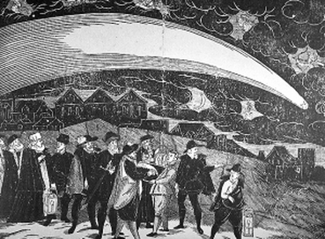

Good news Bad news.
We may expect that eclipses
would have been especially frightening to early humans. After predicting the
seasons, eclipse prediction may have been one of the earliest astronomical
activities.
7. Why would an eclipse be so scary for early man?
FRCMNN learning link.
Import men in the history of Astronomy.
How to link them?
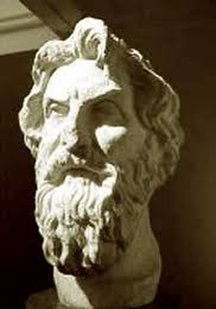
Aristarchus 310-230 BC was a Greek mathematician and astronomer who is celebrated as the exponent of a Sun-centred universe and for his pioneering attempt to determine the sizes and distances of the Sun and Moon.
8.What did Aristachus say about the sun and the solar system?

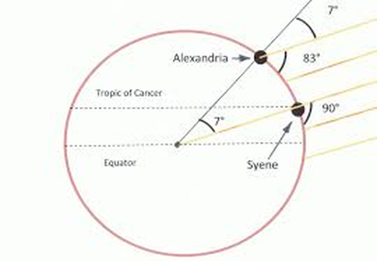
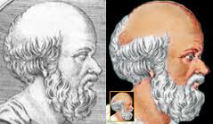
Eratosthenes of Cyrene 276-197 BC
Estimated the circumference of the Earth.
9. How do you know the earth is not flat?

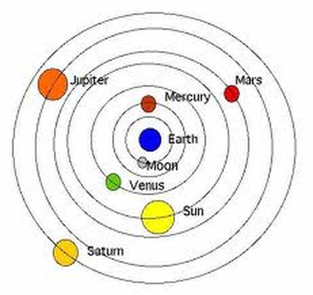
Claudius Ptolemy 85-165AD Geocentric Model earth centered solar system.
Dark Ages The Catholic Church. If the Greeks said it was true because God told the Greeks.
1400 years before the geocentric model was challenged.
10. Why do you think Ptolemy's model lasted so long?
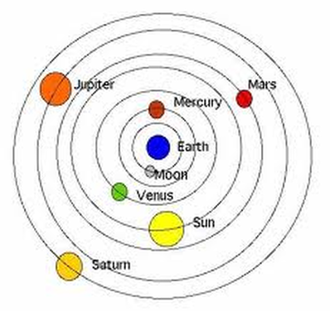
Copernicus, 1473-1543 Copernicus developed a heliocentric model of the Solar System which retained the notion of perfect circular motion,but placed the Sun at the center.
11.Why was Copernicus important to Astronomy?

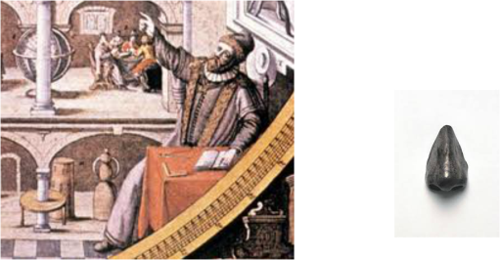
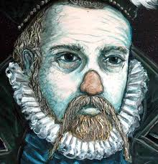
Tyge (Tycho) Brahe 1546-1601
Meticulous observations and measurements of heavenly bodies.
Lost the end of his nose in a duel over a
math problem.
Died by a kidney infection. Mystery??
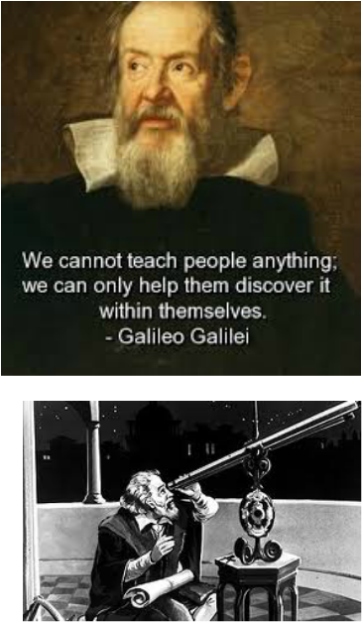
Galileo Galilei 1564-1642
First to use the telescope to view the night sky.
Moon feature maps.
4 Moon of Jupiter.
Sunspots.
12. How did Galileo search the sky?

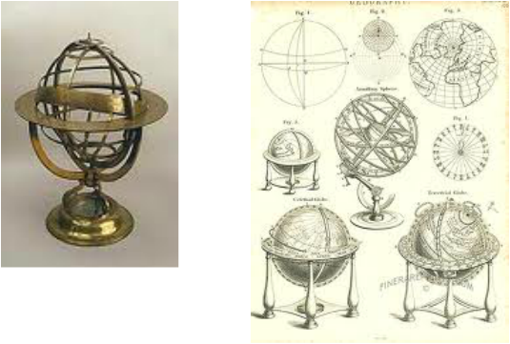
13. Why this idea of perfect circles for the models of the solar system used?
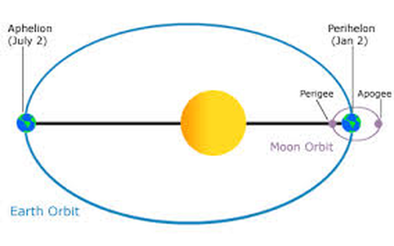
Johannes Kepler 1571-1630 Laws of motion. Worked for Brahe. Killer?
The orbit of the planets are ellipses.
14. Compare a perfect circle and an ellipses?
Still what is the force that causes these object in the sky to move?

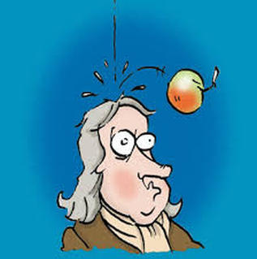
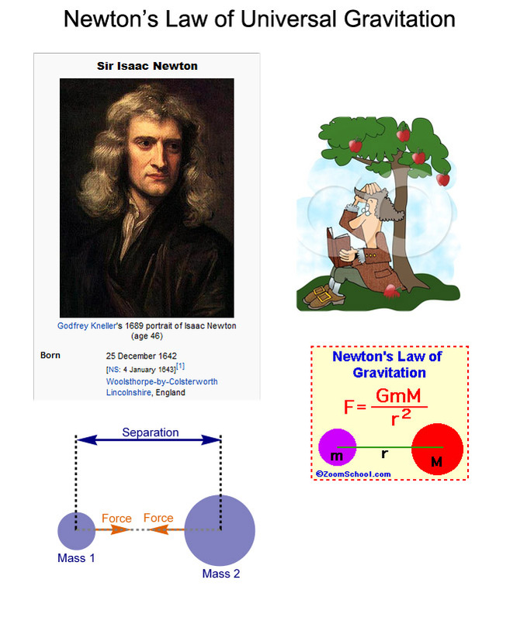
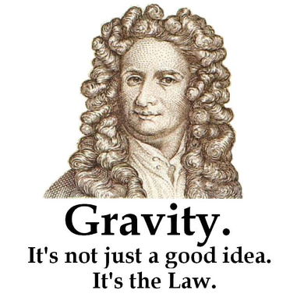
Isaac Newton 1642-1727
The force that runs the solar system,
universe.
Universal Gravity
Amount of Mass Produces X amount of gravity.
15. How does the earth stay in its’ orbit and not fly into the sun?
16. What is the relationship between the amount of mass and the amount of gravity?
AEPCBGKN

The Orbit
Seasons
Star clock
Eratosthenes
Moon

