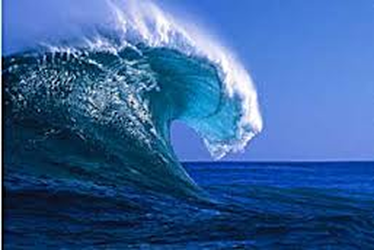
Wave Energy Unit
YouTube Link to WAVES Bill Nye
EM
Thermal Energy
HOMES ICE
HOMES ICE 2

Copy Question 1-12 Red Questions
WAVES Bill
Nye Video
Name____________
Date _____ Period _____
1. What are three things that travel in waves?
2. What are three of the properties of waves?
3. Why does light break into patterns when it is run through thin slits?
4. Do X-rays have higher or lower frequency than light waves?
5. Define wavelength.
6. What causes waves on the ocean?
7. What are the waves in the Earth called (Earthquake waves)?
8. Define frequency.
9. Define amplitude.
10. What kind of wave travels by squeezing and spreading? (give an example)
11. What is it called when a wave bounces back and comes back to the source?
12. What is Sonar?
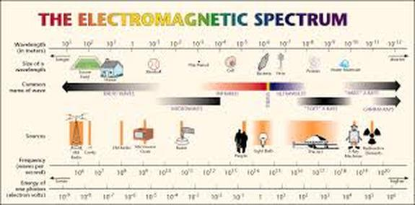

YouTube Link Electromagnetic Spectrum Basics
Copy questions before the clip.
13. What is the electromagnetic spectrum?
14. What is a long wave energy?
15. Why would you not lose any sleep if you worked on a radio teleoscope?
16. List two telescopes that collect other forms of energy other than light and radio?
17. List the color energies in the EM spectrum?
18. How do we know plants do not use green light energy?
19. If something is red is it really red or what is it doing?

Wave is any disturbance that transmits energy through matter or space.
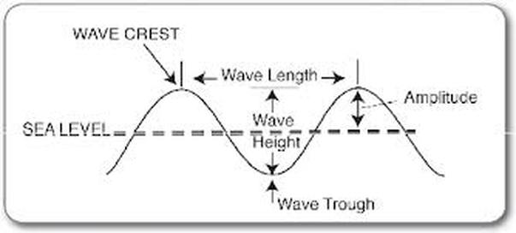
Parts of a wave.
Amplitude. Reflection of energy.
Crest Top of the wave.
Trough bottom of the wave.
Wavelength is the distance between two adjacent crests or compressions.
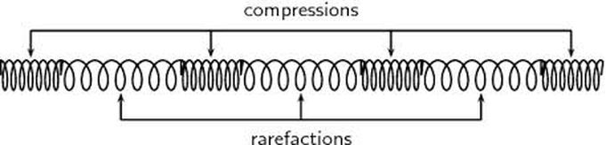
Compressional Waves Waves that the particles vibrate back and forth in the direction of the energy.
Medium the material the vibration is traveling in.
Compression is the section of the wave where the particles crowd together.
Rarefraction the section where the particles spread apart.
Sound travels the fastest in a solid than liquid, than poorest in air.

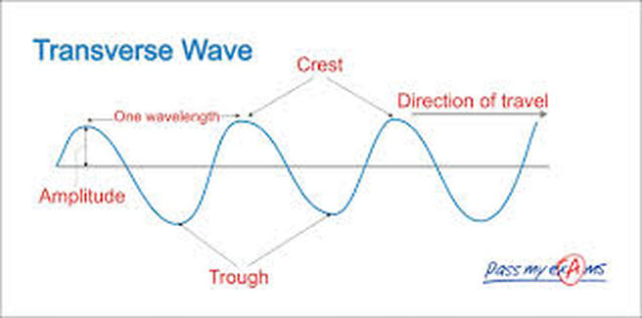
Transverse Wave the vibration is perpendicular to the direction of the energy.

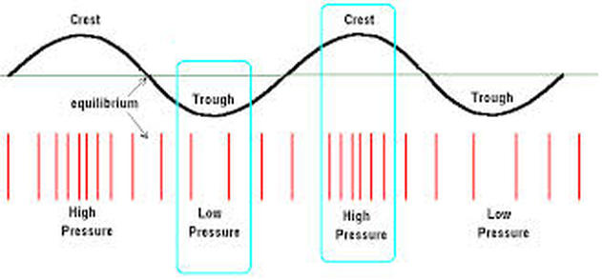
Compare transverse and compressional waves.

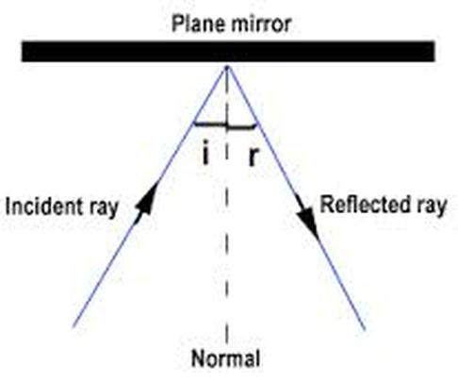
Reflection occurs when a wave bounce back after striking a barrier.
Echoes sound reflection.
Reflected waves. The reflection depends on the surface the waves are hitting.

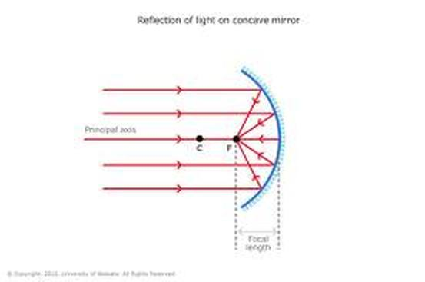
Concave surface collects waves.
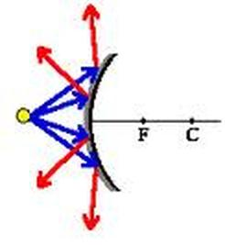
Convex surface spreads the waves apart.
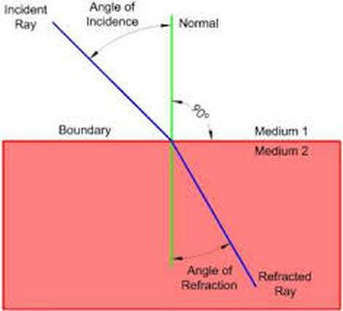
Refraction is the bending of a wave as
it passes at an angle from one medium to another. Broken pencil effect.

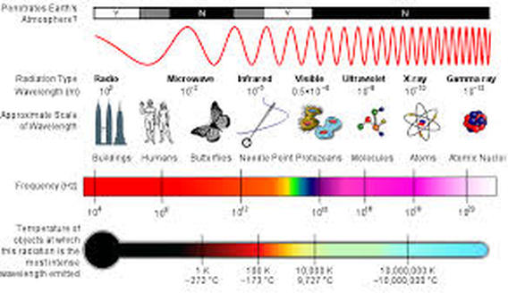

EM WAVES
do not require a medium, travel through solids, liquids, and gases.
E-M waves are a form of radiation, fields of electric and magnetic energy, that vary in strength.
Travel in space.
Electromagnetic waves need no medium, therefore they have but one speed, the speed of light.
186,300 miles per second or 300,000,000 meters per second.
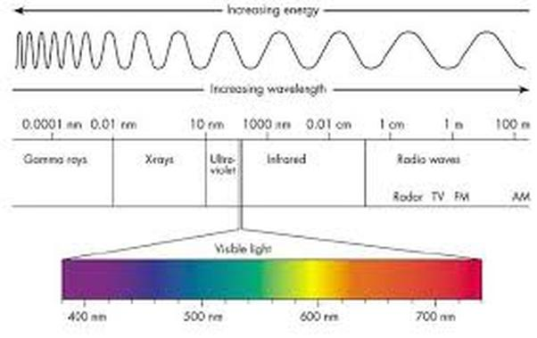
ROYGIV visible light. Red,(low energyand low frequency) Orange, Yellow, Green Blue,Indigo, and (high frequency and high energy)Violet. White light is a combination of element light..﻿

Three Light Spectrums
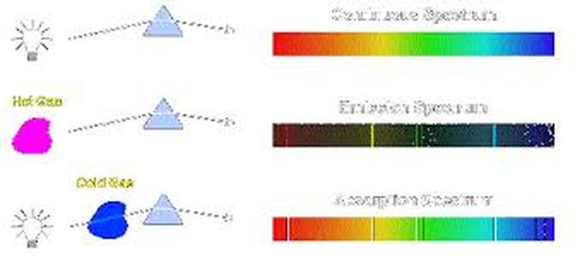

- Continuous the light of all elements side by side.
- Emission element light spectrum.
- Absorption an element's light has been absorded by a gas cloud of that element light. Elements in a star, planet, light from any object.

Why do you see different lines when you look through diffraction grating?

What are the 3 types of spectra?
A—cool gas—colored background—black lines
C—prism
E—hot gas—black background—colored lines
Emission is seen on earth.

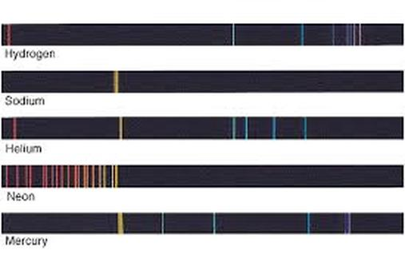
What is Doppler Effect?
What is happening when light is red shifted?
What does red shift tell us about the universe?
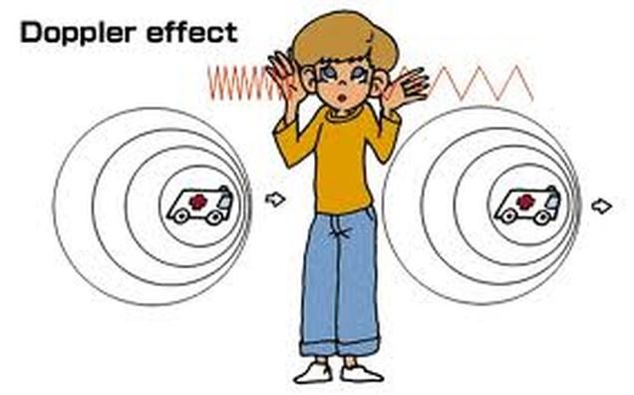
Doppler Effect

Change in frequency due 1to a sound source moving.
Three parts of the Doppler Effect
1.Stationary sound what the sound really is.
2. Higher Frequency Shift waves pile up in front of the moving object.
3. Lower Frequency Shift waves spread out behind the moving object.
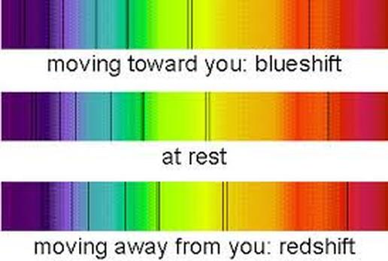
BLUE SHIFT
RED SHIFT
at rest the position on earth the standing wave.
How fast. At what speed. Rotation.
Create a free website with

