Weather Map
Weather map reading

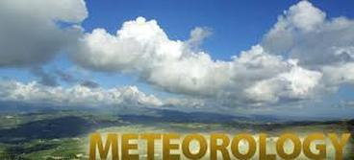
Meteorology -pg.436 The science that deals with the
phenomena of the atmosphere, especially weather and
weather conditions.

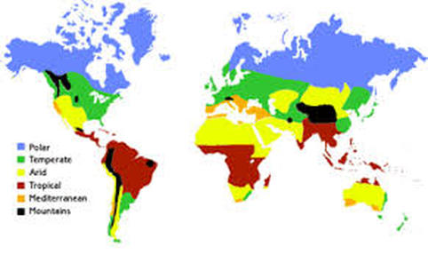
Climate? pg. 466
Climate is the average weather usually taken over a 30-year time period for a particular region and time period. Climate is not the same as weather, but rather, it is the average pattern of weather for a particular region

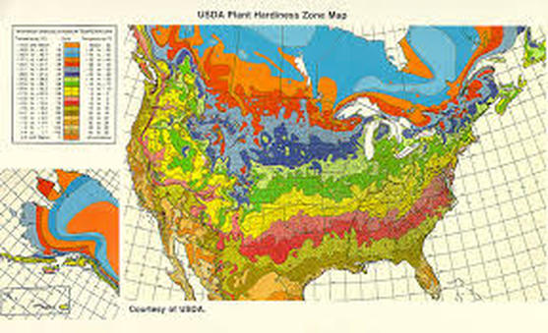
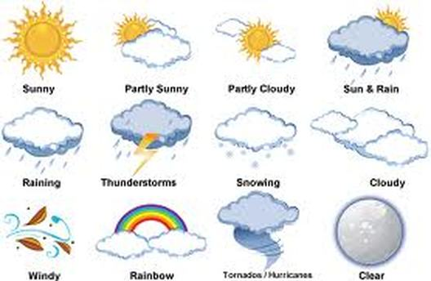
Weather? pg.436
The weather is just the state of the atmosphere at any time, including things such as temperature, precipitation, air pressure and cloud cover. Daily changes in the weather are due to winds and storms. Seasonal changes are due to the Earth revolving around the sun.

What causes weather? pg.436
Differences in heating and air on the move.
Because the Earth is round and not flat, the Sun's rays don't fall evenly on the land and oceans. The Sun shines more directly near the equator. The polar regions are at such an angle to the Sun they have colder temperatures. These differences in temperature create a restless movement of air and water in great swirling currents to distribute heat energy from the Sun across the planet. When air in one region is warmer than the surrounding air, it becomes less dense and begins to rise, drawing more air in underneath. Elsewhere, cooler denser air sinks, pushing air outward to flow along the surface and complete the cycle.
Climate Change?pg. 474
Climate change represents a change in long-term weather patterns. They can become warmer or colder. Annual amounts of rainfall or snowfall can increase or decrease.
Global Warming? pg.381
Global warming refers to an average increase in the Earth's temperature, which in turn causes changes in climate. A warmer Earth may lead to changes in rainfall patterns, a rise in sea level, and a wide range of impacts on plants, wildlife, and humans. When scientists talk about the issue of climate change, their concern is about global warming caused by human activities.
Elements of weather.
Temperature
Humidity
Cloudiness
Precipitation
Air pressure
Wind speed and direction
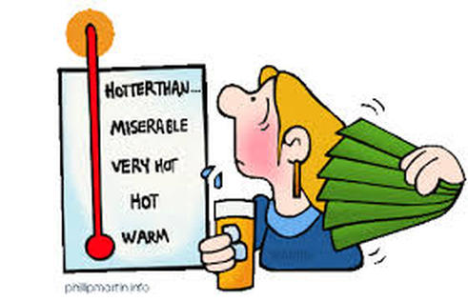
Temperature pg.696
Temperature is a degree of hotness or coldness the can be measured using a thermometer. How much heat is there. Temperature is measured in degrees on the Fahrenheit. Celsius used in science.
0 degrees
100degrees,

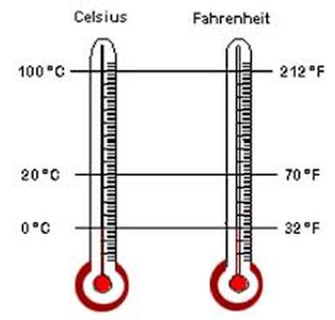
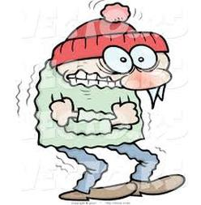
Wind Chill
The wind chill index is the temperature your body feels when the air temperature is combined with the wind speed. The higher the wind speed the faster exposed areas of your body lose heat and the cooler you feel.

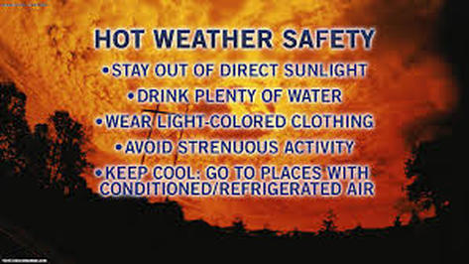
HEAT WAVE SAFETY TIPS:
1. Slow down!
2. Wear lightweight, light-colored clothing.
3. Drink plenty of water.
4. Air-conditioning, fan.

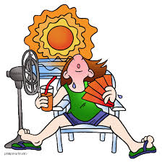
Humidity pg 391 The amount of water in the air.

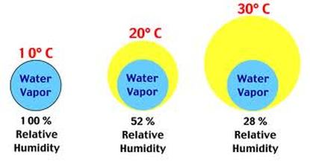
Relative Humidity The percent of water there at a specific temperature.

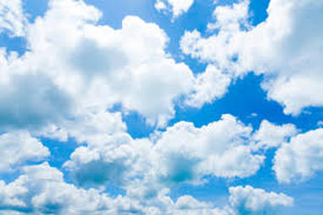
Cloud pg. 396 -401
A cloud is a large collection of very tiny droplets of water or ice crystals. The droplets are so small and light that they can float in the air.

Why do clouds float?
A cloud is made up of liquid water droplets. A cloud forms when air is heated by the sun. As it rises, it slowly cools it reaches the saturation point and water condenses, forming a cloud. As long as the cloud and the air that its made of is warmer than the outside air around it, it floats!

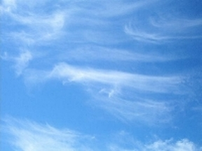
Cirrus Clouds
Cirrus clouds are the most common of the high clouds. They are composed of ice and are thin, wispy clouds blown in high winds into long streamers. Cirrus clouds are usually white and predict fair to pleasant weather. By watching the movement of cirrus clouds you can tell from which direction weather is approaching. When you see cirrus clouds, it usually indicates that a change in the weather will occur within 24 hours.

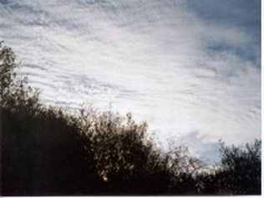
Cirrostratus clouds are thin, sheetlike high clouds that often cover the entire sky. They are so thin that the sun and moon can be seen through them. Cirrostratus clouds usually come 12-24 hours before a rain or snow storm.

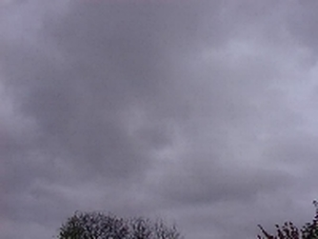
Stratus Clouds
Stratus clouds are uniform grayish clouds that often cover the entire sky. They resemble fog that doesn't reach the ground. Light mist or drizzle sometimes falls out of these clouds.

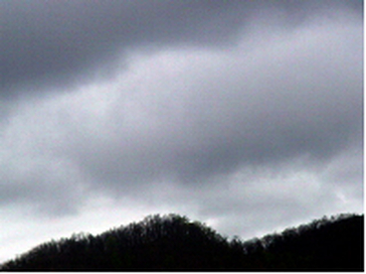
Nimbostratus clouds form a dark gray, wet looking cloudy layer associated with continuously falling rain or snow. They often produce precipitation that is usually light to moderate.

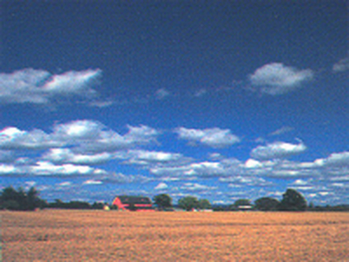
Cumulus Clouds
Cumulus clouds are white, puffy clouds that look like pieces of floating cotton. Cumulus clouds are often called "fair-weather clouds". The base of each cloud is flat and the top of each cloud has rounded towers. When the top of the cumulus clouds resemble the head of a cauliflower. These clouds grow upward and they can develop into giant cumulonimbus clouds, which are thunderstorm clouds.
Shower
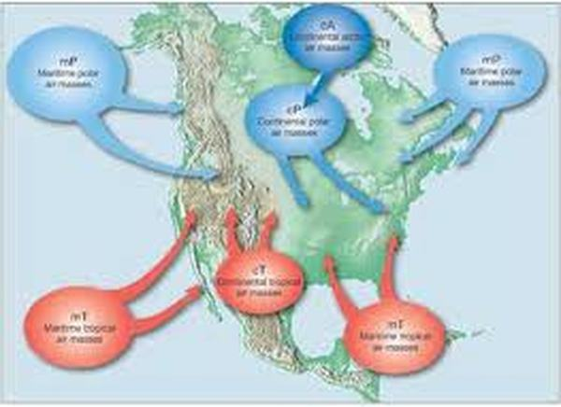
Air mass pg 436
An air mass is an extremely large body of air whose properties of temperature and moisture content (humidity), at any given altitude, are fairly similar in any horizontal direction. Air masses can cover large (hundreds of miles) areas. Air masses can control the weather for a relatively long time period: from a period of days, to months. Most weather occurs along the periphery of these air masses at boundaries called fronts. There are 4 general air mass classifications categorized according to the source region: polar, tropical, continental and marine.

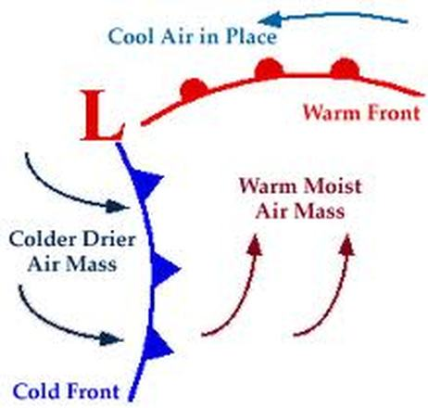
Front pg 439
A front is a boundary between two different air masses, resulting in stormy weather. A front usually is a line of separation between warm and cold air masses.

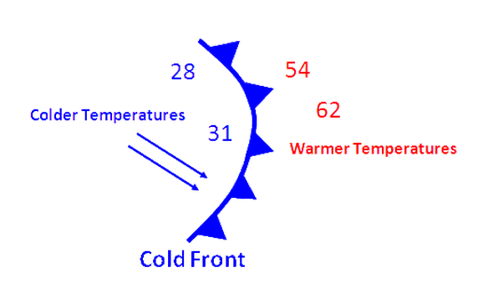
Cold front pg 440
A cold front is a boundary between two air masses, one cold and the other warm, moving so that the colder air replaces the warmer air. A cold front is represented as a blue line with the teeth pointing toward the direction on movement.

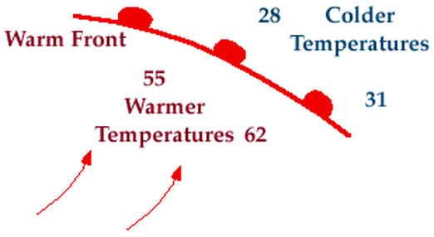
Warm front pg 441
A warm front is a boundary between two air masses, one cool and the other warm, moving so that the warmer air replaces the cooler air. A warm front is represented as a red line with half circles pointing toward the direction on movement.

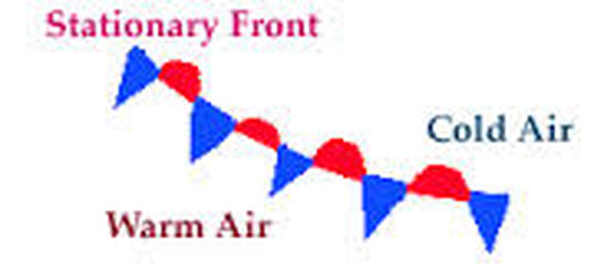
Stationary front pg 441
A stationary front is a boundary between two air masses that more or less doesn’t move, but some stationary fronts can wobble back and forth for several hundred miles a day. A stationary front is represented as an alternating warm and cold front symbol.

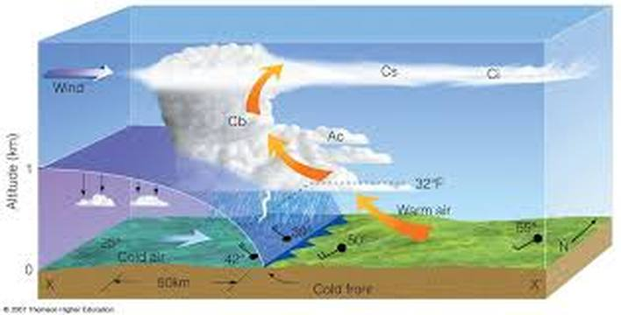
Thunderstorm and front movement pg 440
Cold air is more dense then warm air. A cold front advances on a warm air mass.
The warm air with moisture is pushed up rapidly and forms tall a thunderhead. Condensation is rapid.
Violent storm conditions. Hail, lightning, tornadoes.

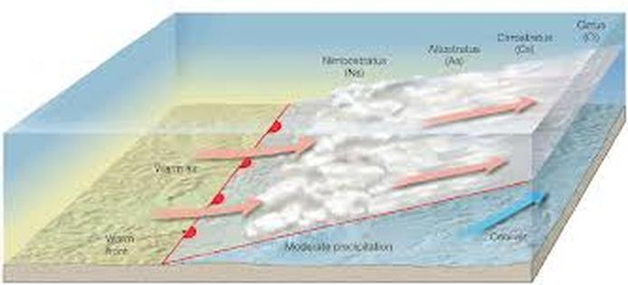
Steady Rain Storm and front movement pg 440
Warm moist air slowly slide up and over the cold air mass. Condensation rate is slow, thus producing a long steady rain.

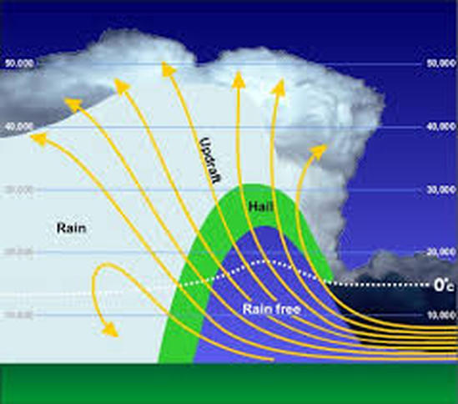
Thunderstorm pg445
A thunderstorm is a storm with lightning and thunder. Its produced by a cumulonimbus cloud, usually producing gusty winds, heavy rain and sometimes hail.

Are thunderstorms dangerous?
Yes, despite their small size, all thunderstorms are dangerous. Every thunderstorm produces lightning, which kills more people each year than tornadoes.
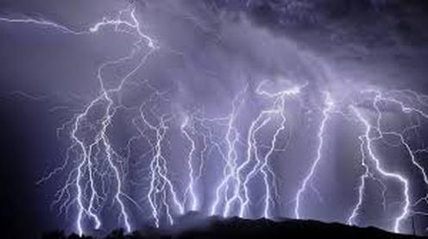
Lightning pg 447
What is lightning?
Lightning is a bright flash of electricity produced by a thunderstorm. All thunderstorms produce lightning and are very dangerous. If you hear the sound of thunder, then you are in danger from lightning. Lightning kills and injures more people each year than hurricanes or tornadoes; between 75 to 100 people.
What causes thunder?
Thunder is caused by lightning. When a lightning bolt travels from the cloud to the ground it actually opens up a little hole in the air, called a channel. Once then light is gone the air collapses back in and creates a sound wave that we hear as thunder. The reason we see lightning before we hear thunder is because light travels faster than sound!
Can you tell how far away a storm is?
Yes, you can use thunder to tell how far away a storm is. Next time you see a storm, count the number of seconds between when you see the lightning and hear the thunder. Take the number of seconds and divide by 5 and that will tell you how far away the storm is in miles. For example: If you counted 10 seconds between the lightning and the thunder, the lightning is 2 miles away!
5 seconds = one mile.

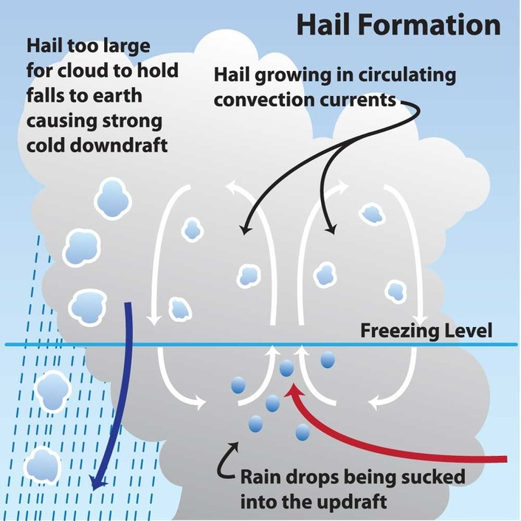
What is hail? pg 403
Hail is created when small water droplets are caught in the updraft of a thunderstorm. These water droplets are lifted higher and higher into the sky until they freeze into ice. Once they become heavy, they will start to fall. If the smaller hailstones get caught in the updraft again, they will get more water on them and get lifted higher in the sky and get bigger. Once they get lifted again, they freeze and fall. This happens over and over again until the hailstone is too heavy and then falls to the ground.

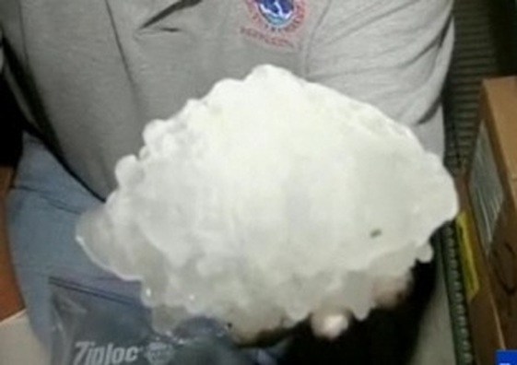
What is the largest hailstone recorded in the United States?
According to the National Weather Service, the largest hailstone is 8 inches in diameter and weights approximately 2 pounds. It fell in Vivian, South Dakota on July 23, 2010.

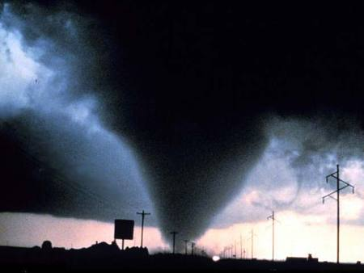
Tornado pg447
A tornado is a violent rotating column of air extending from a thunderstorm to the ground. The most violent tornadoes are capable of tremendous destruction with wind speeds of up to 300 mph. They can destroy large buildings, uproot trees and hurl vehicles hundreds of yards. They can also drive straw into trees. Damage paths can be in excess of one mile wide to 50 miles long. In an average year, 1000 tornadoes are reported nationwide.

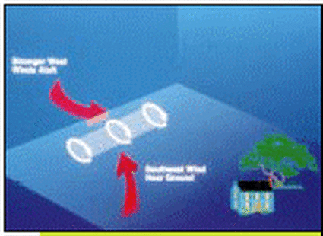
How do tornadoes form? pg 447
Most tornadoes form from thunderstorms. You need warm, moist air from the Gulf of Mexico and cool, dry air from Canada. When these two air masses meet, they create instability in the atmosphere. A change in wind direction and an increase in wind speed with increasing height creates an invisible, horizontal spinning effect in the lower atmosphere. Rising air within the updraft tilts the rotating air from horizontal to vertical. An area of rotation, 2-6 miles wide, now extends through much of the storm. Most strong and violent tornadoes form within this area of strong rotation.

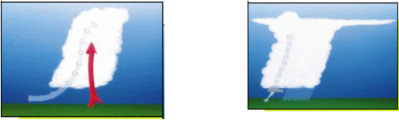
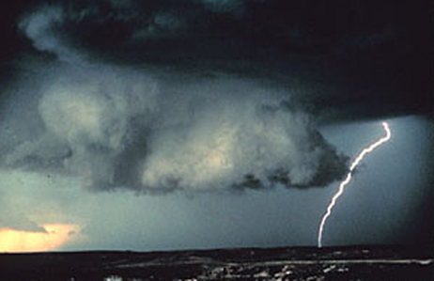
Wall cloud pg447
A wall cloud is an abrupt lowering of a rain-free cumulonimbus base into a low-hanging accessory cloud. A wall cloud is usually situated in the southwest portion of the storm. A rotating wall cloud usually develops before tornadoes or funnel clouds.

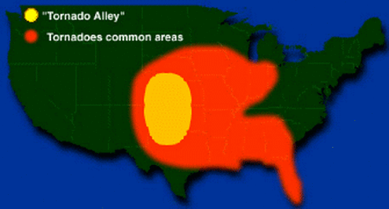
Where are tornadoes most likely to occur?
The geography of the central part of the United States, known as the Great Plains, is suited to bring all of the ingredients together to forms tornadoes. More than 500 tornadoes typically occur in this area every year and is why it is commonly known as "Tornado Alley". Texas, Oklahoma, Kansas, Nebraska, South Dakota, North Dakota, Iowa, Missouri, Ar

TORNADO WATCH - Tornadoes are possible in your area. Stay tuned to the radio or television news.
TORNADO WARNING - A tornado is either on the ground or has been detected by Doppler radar. Seek shelter immediately!
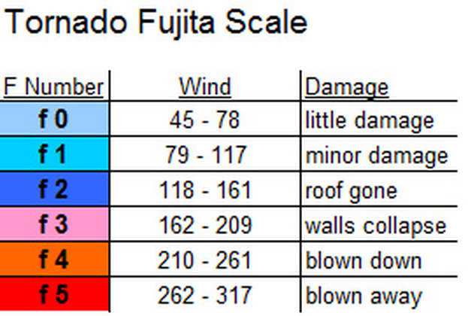
Fujita Scale of Tornado Intensity

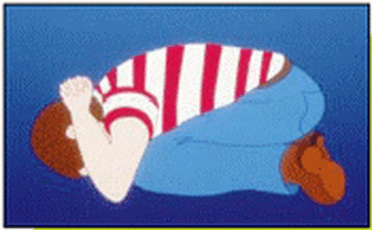
Duck and Cover
Tornado Safety Tips
BEFORE A TORNADO: Have a disaster plan. Make sure everyone knows where to go in case a tornado threatens. Make sure you know which county or parish you live in. Prepare a kit with emergency food for your home. Have enough food and water for at least 3 days.
DURING A TORNADO: Go to a basement. If you do not have a basement, go to an interior room without windows on the lowest floor such as a bathroom or closet. If you can, get under a sturdy piece of furniture, like a table. If you live in a mobile home get out. They offer little protection against tornadoes. Get out of automobiles. Do not try to outrun a tornado in your car, leave it immediately. If you’re outside, go to a ditch or low lying area and lie flat in it. Stay away from fallen power lines and stay out of damaged areas.
IF YOU’RE AT SCHOOL DURING A TORNADO: Every school should have a disaster plan and have frequent drills. Basements offer the best protection. Schools without basements should use interior rooms and hallways on the lowest floor away from windows. Crouch down on your knee.

L
Low Pressure pg 416
A low pressure system is a whirling mass of warm, moist air that generally brings stormy weather with strong winds. When viewed from above, winds spiral into a low-pressure center in a counterclockwise rotation in the Northern Hemisphere. A low pressure system is represented as a big, red L
H
High Pressure pg 416
A high pressure system is a whirling mass of cool, dry air that generally brings fair weather and light winds. When viewed from above, winds spiral out of a high-pressure center in a clockwise rotation in the Northern Hemisphere. These bring sunny skies. A high pressure system is represented as a big, blue H.
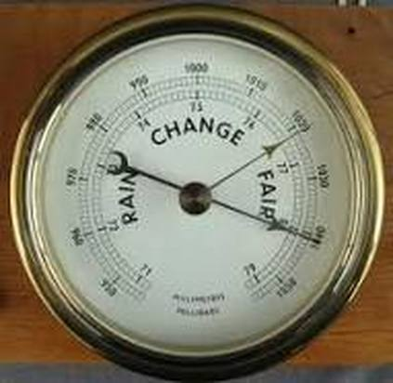
Barometer measures atmospheric pressure. Weather forecasting Dropping pressure storm weather. High pressure fair.

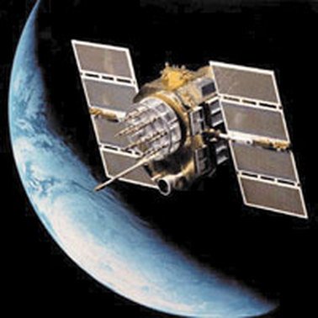
Weather satellite?
A weather satellite is a type of satellite that is primarily used to monitor the weather and climate of the Earth. Satellites can be either polar orbiting, seeing the same swath of the Earth every 12 hours, or geostationary, hovering over the same spot on Earth by orbiting over the equator while moving at the speed of the Earth's rotation. These meteorological satellites see more than clouds and cloud systems. City lights, fires, effects of pollution, auroras, sand and dust storms, snow cover, ice mapping, boundaries of ocean currents, energy flows, etc., are other types of environmental information collected using weather satellites.

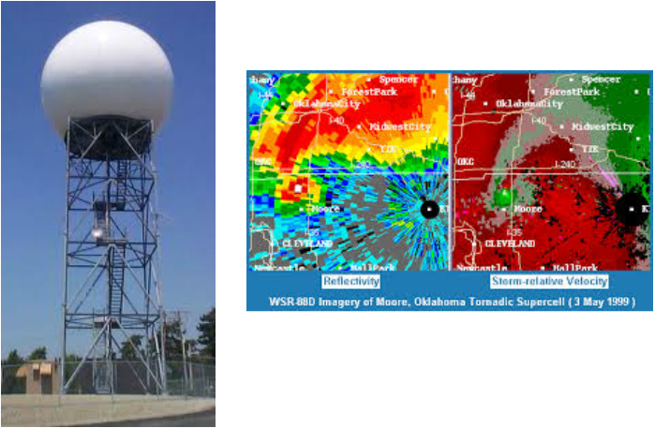
Doppler Radar pg449
Doppler Radar detects precipitation intensity, wind direction and speed, and provides estimates of hail size and rainfall amounts. Doppler Radar gives forecasters the capability of providing early detection of severe thunderstorms that may bring strong damaging winds, large hail, heavy rain, and possibly tornadoes. Combined with satellites, radar gives forecasters the ultimate tools to provide accurate forecasts and advanced severe weather warnings.
How does Doppler Radar work?
Doppler Radar gets its name from the Doppler Effect. Have you ever listened to a train whistle as it was coming toward you? You probably noticed that the pitch of the whistle changed as the train passed you and moved away. This change in the frequency of sound is called the Doppler Effect. Doppler Radar measures the changes in the frequency of the signal it receives to determine the wind.

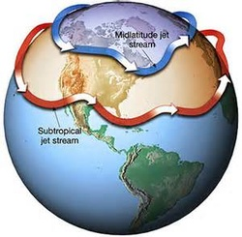
Jet Stream pg421 river of air in the atmosphere that moves west to east. Divides warm and cold air.

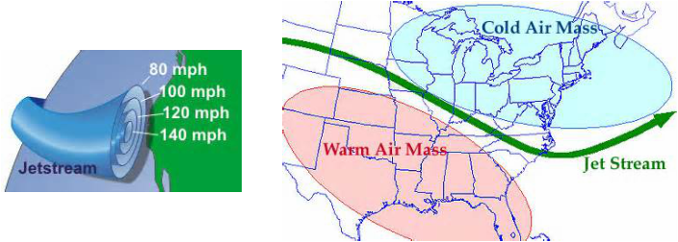

Create a free website with

