**ANSWERS WORKSHEET FOR CARBOXYLIC ACIDS AND ESTER**

1. **Provide the IUPAC name for each of the following compounds.**



**Butyl ethanoate 4 hydroxy benzoic acid**

**2 chloro benzenoic acid**





**Phenyl butanoate cyclohexyl ethanoate 3, 4 dihydroxy pentanoic acid**

**2. Write the full or condensed structural formula for each of the following compounds.**

Butyric acid isopropyl hexanoate

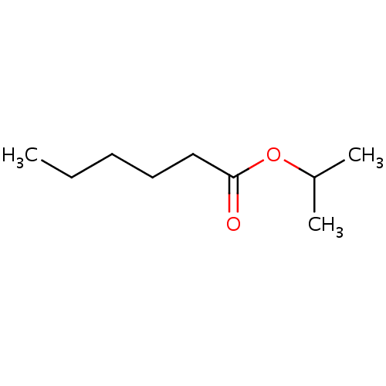

Flat structure

acetic acid cyclopentyl benzoate

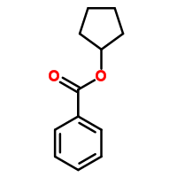

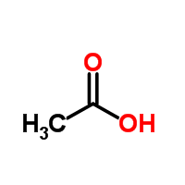

2-hydroxy-3, 5-dimethyl heptanoic acid phenyl pentanoate

